IN 45
ELECTRONIC ICU BED, COLUMN MOTORS
Click for detailed video of the product
- Linak brand Columnar Motors
- Electrical operated backrest, height and legrest adjustment
- Electrical operated Trendelenburg, Reverse Trendelenburg, fowler and vascular position
- Footrest adjustment by ratchet
- Remote control for adjusting positions
- Auto-CPR
- Auto Regression system on backrest
- Auto contour
- Hygienic design (PP), lockable and tuck away side rails
- Easy removable ABS mattress platform
- X-ray translucent HPL backrest
- Removable head and footboards
- Electrostatic epoxy painted metal frame
- Height adjustable stainless steel IV pole
- Plastic crash bumpers
- Central Lockable Castors, 150 mm
- Angle indicator for backrest
- Angle indicator for Trendelenburg and reverse Trendelenburg positions
- Cardiac chair position
- Shock position
- Semi-Fowler position
- Bed exit position
- Examination position
- CPR activation with single button
- Foot end nurse control panel
- Control panels embedded on side rails; 2 for patient; 2 for nursing staff
- Activation key at remote control to prevent any undesired positions
- Dual sided manual CPR levers at backrest
- Rechargeable Battery Backup
- X-ray cassette holder
- Urine bag holder
- Integrated Linak brand weight scale system (Optional)
- Bed size extension (optional)
- IPX6 standard electronic system
Other Electronic icu bed
 | TECHNICAL DETAILS
 | Overall Length: 216 cm | Under Bed Clearance: 15 cm
 | Overall Width: 102 cm | Product Weight: 130 kg
 | Height: 44-84 cm | Safe Working Load: 250 kg
 | Trendelenburg : 0°-16° | Power In: 1.5A max. At 230V AC 50-60 Hz
 | Reverse Trendelenburg: 0°-16° | Electrical Shock Protection: Class I, Type B
 | Backrest Angle: 0°-70° | Liquid Ingress Protection: IPX6
 | Legrest Angle: 0°-35° | Batteries: 2x 12V Series Connected, sealed, rechargeable, Lead / Acid gel,1.2 amp hrs.
 | Castor Diameter: 15 cm

ACCESSORIES
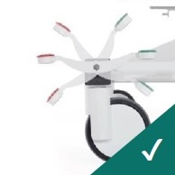
Central Brake Castors 150 mm
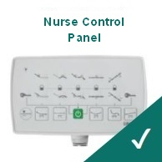
Foot-end Nurse Control Panel
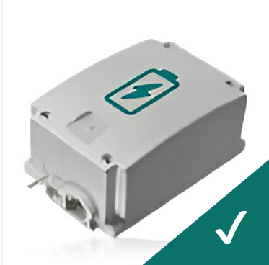
Rechargeable Battery Backup
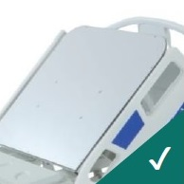
X-Ray Translucent Backrest with Cassette Holder
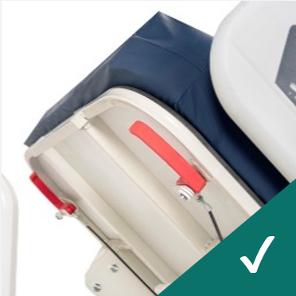
Dual Sided Manual CPR at Backrest
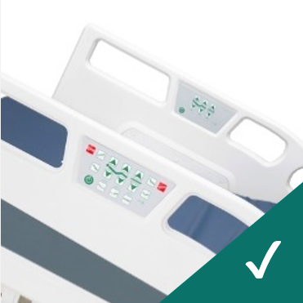
Control Panels Embedded on Side Rails
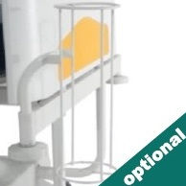
Oxygen Cylinder Holder
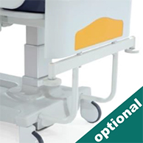
Stationary Headboard
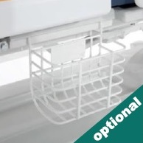
Urine Bag Basket
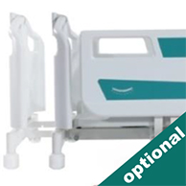
Bed Extension
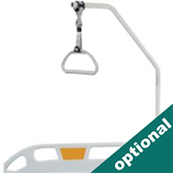
Lifting Pole
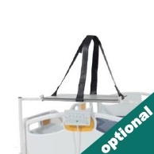
Monitor & Defibrillator Shelf
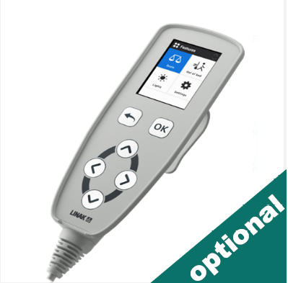
Weighing Scale System
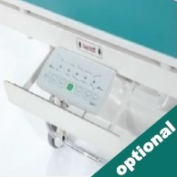
Nurse Panel Shelf
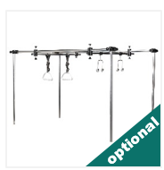
Orthopedic Traction System
COLOR CHART
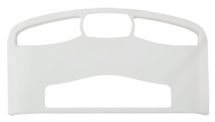
P01
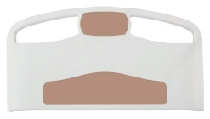
P02
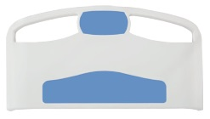
P03
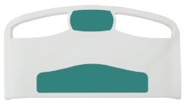
P04
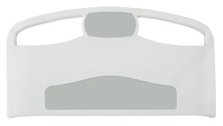
P05
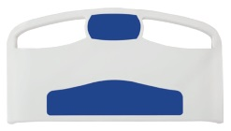
P06
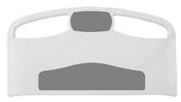
P07
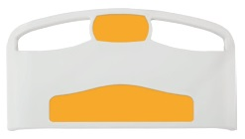
P08

